Using The Publisher Center
  - A quick-reference to features and procedures

Logging In
- Type your username and your password.
- Select an option:
  - Auto login until logout – remembers both your user name and password until you log out of Windows.
  - Save my user name – remembers your user name, but doesn’t remember your password.
  - Always ask for my user name and password -- doesn’t remember your name and password.
- Click Login. The Publisher Center logs you in and displays The Publisher Center Detailed screen.

Detailed vs. Summary screens
The Detailed screen is the default. Click Summary to see that screen.
The Detailed screen displays all the information about an article, while the summary screen shows less information. Each display lists information about the articles in columns. The columns are:
Publisher | Journal | Volume | Issue | Article ID
DOI | Article Type | Companion Article* | Section* | Subsection*
Corresponding Author | Authors* | Total # Figs | Total # Color Figs | Supplemental Data*
Ms Received Date | Accepted | AoP to DataPages | Copy Edited Date | Ms to Comp
Proof to Author | First Pages ACTReturn | Author CX | RP1 | RP2
Approved | Folio Start | Folio End | Remarks*
Columns listed with an asterisk only appear on the Detailed screen.

The Filter Panel
The Filter panel contains many of the items and commands you use to search for or print the results.
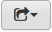 | Click the Export button to display a Printer Friendly format, Export to Excel, or Export to PDF.
 | Click the Toggle button to display or hide the search tools.
 | Click the Save Filters button to save the current filter or clear the filter.

Using the Filter Panel

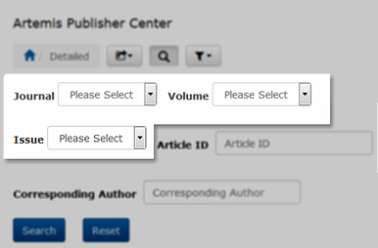
Journal, Issue, Volume
The Filter panel has three interrelated controls: Journal, Volume, and Issue. You can’t select an Issue without first selecting a Volume and Journal, and you can’t select a Volume without first selecting a Journal.
Each control is a drop-down list, and it only displays choices that are available to you. That is, you can only select the Journals that have articles in the database.
You don’t need to select all three items. You can select a Journal and click Search. The Publisher Center then displays all matching Journal entries. Click Reset to reset search parameters.

Article ID and Corresponding Author
Both of these controls work in the same way. Type the full or partial Article ID or Corresponding Author name into these controls. As you type, The Publisher Center begins to display matching entries. Pick an entry from the list or continue typing, narrowing down your choices.
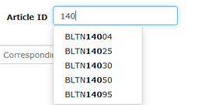 | 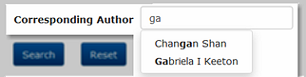
Once you set the filters, click Search to find matching results. Click Reset to reset search parameters.

Retrieving Articles
Once you’ve found the desired article, navigate to a column. If the entry is blue, you can click to view or download the file. The Publisher Center supplies the files in Word or PDF formats.
